# Leather Strap 40mm Watch

Price: $140.00 Color: Brown/Black

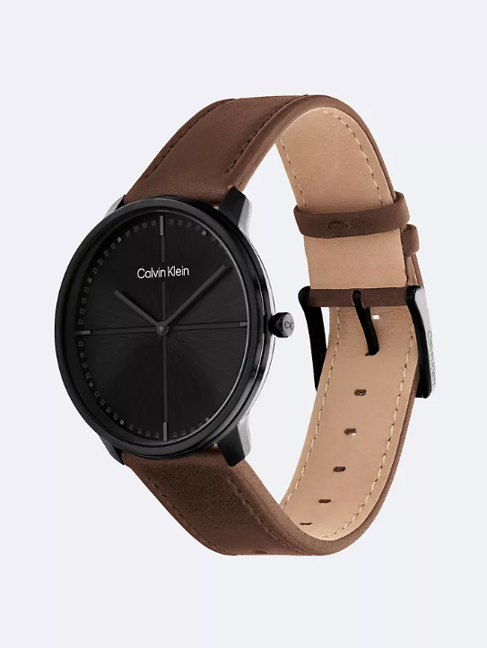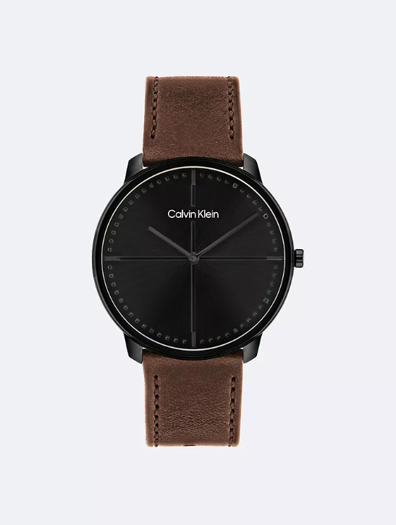

## **About the Leather Strap 40mm Watch:**

Minimalist feel. Clean, quadrant-inspired dial surrounded by a smooth, sculptural case featured on a leather strap.

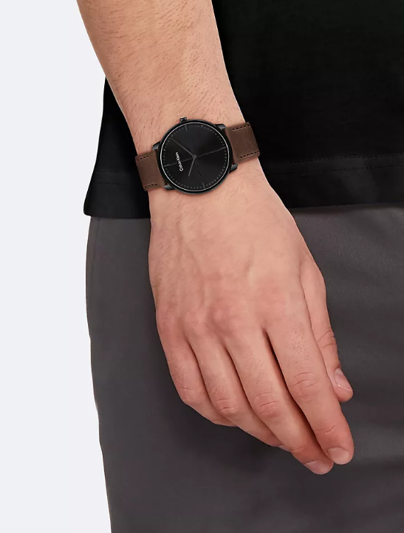**Product Details:**

* Stainless steel, black IP coated or gold plated case
* Leather strap
* Tongue buckle closure
* 2 hand design
* Quartz movement
* 40mm case size, 20mm lug width
* Water resistant 3 bar
* 2 year international warranty
* All watches + jewelry come in a box

Style #: 43041560-001

Universal Style #: 25200156